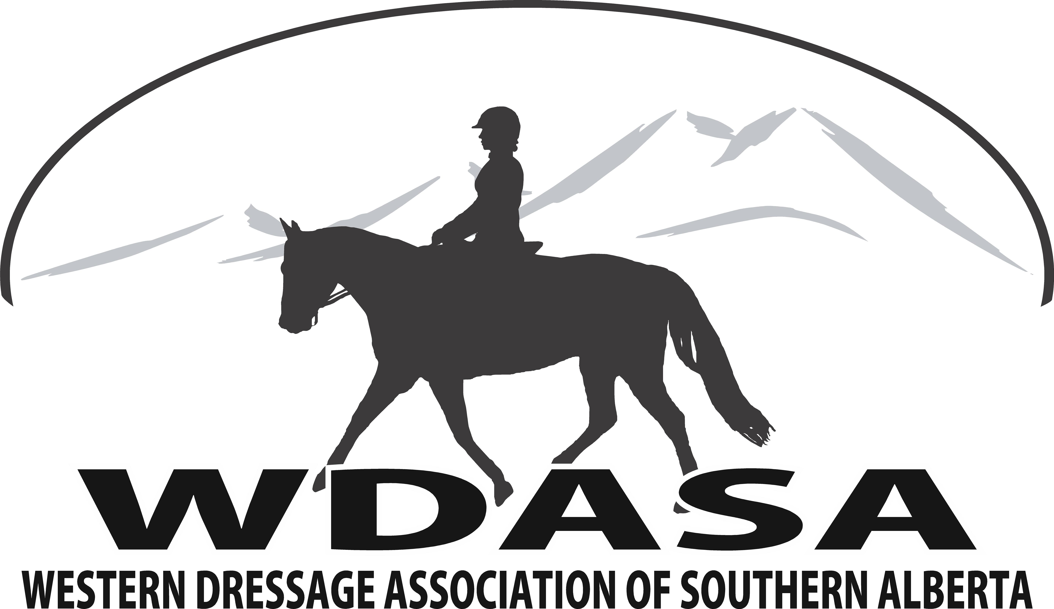
2018 Application for Membership
C/O Linda Anderson
RR#4 Site 11 Box 14 Olds AB, T4H 1T8
E-mail: info@wdasa.ca
Mission Statement To actively promote Western Dressage in Southern Alberta, from Ponoka to the Southern Alberta Border, East to the Saskatchewan Border and West to the BC Border.
To provide a venue for equestrian riders to access coaching, lessons, testing, and showing in Western Dressage that is open to riders of all levels, in all disciplines at an economic cost.
____**Single Membership ($25.00) ____***Family Membership ($40.00)
PLEASE PRINT:
Name: _________________________________ WDASA Membership #: __________________________
Address: ____________________________________ City: ___________________________________________
Postal Code: _________________________________ Phone Number: _________________________________
E-Mail Address: ______________________________ AEF#: _________________________________________ (Newsletters will be sent to this address) (Mandatory to participate in any WDASA Event)
** Single Member must be over 18 years of age *** Family membership- please list names and ages of children under 18 years of age Persons over 18 years of age must register separately. Each family group must have one adult member.
To be eligible for Year End Awards, WDASA Membership must be purchased by May 1st, 2018.
OTHER FAMILY MEMBER NAMES BIRTH YEAR

I hereby consent to share my personal contact information, to take and use photographs &/or digital images in printed or electronic publications for promotion of Western Dressage. ____________ Initials
Applicant’s Signature: ____________________________________ Date: ___________________________
Total payment of $___________ is attached (Chq # ___________ Cash ____________)
Our Philosophy & Objective – WDASA is a non-profit organization open to riders at all levels, in all disciplines, with all breeds of horses. The prime objective of the association is the correct development of the horse so that the horse becomes an athlete who is a pleasure to ride, and who works in harmony with the rider. The result of this training is a horse that is calm, supple, loose, balanced and flexible. The horse is also confident and willing to perform the correct basics with little effort. The safety and well-being of all our riders and horses at all times is paramount and our first priority.
WDASA promotes the sport of Western Dressage through schooling shows, clinics, and fun days. Members can view our website for upcoming events and will receive emails regarding such events at www.wdasa.ca Members will be eligible for year end awards. For information regarding tests and rules members can view them at:
WDAA Tests: http://westerndressageassociation.org/wdaa-tests/
USEF Western Dressage Rules: https://files.usef.org/assets/YMOH1DjPYWw/30-wd.pdf

